All code available on github at: <https://github.com/RebelShadow/Capata-Andrei-Bogdan_30332_II/tree/main/LAB/lab3>

Ex1:

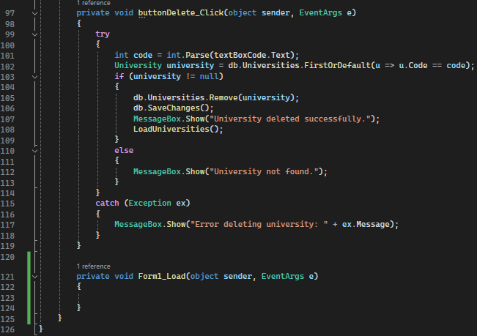

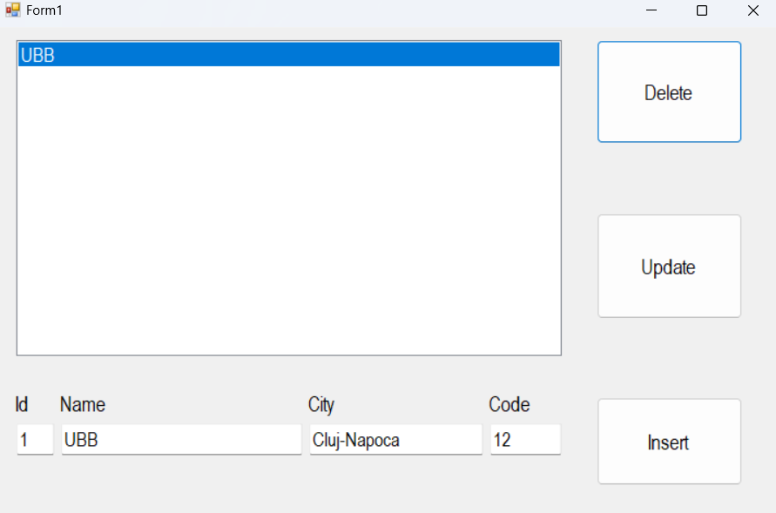

Ex2



